

|  |
| --- |
| MCTR903 |
| **The Furuta-Pendulum** |
| Project Proposal |

|  |
| --- |
| Mona Farouk  2. Ahmed Zaghloul ID: 43-1  3. Bishoy Atef ID: 43-  4. John Gameel ID: 43-  5. Abdo Saad ID: 43-  Proposed to: Prof. Ayman Elbadawy  10-19-2021 |

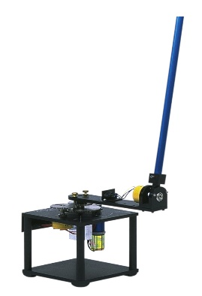

**The** **Furuta-Pendulum**

The Furuta-Pendulum or the Rotational Pendulum system is an underactuated planar system (which has fewer number of actuators than the degrees of freedom). It consists of an arm rotating in the horizontal plane and a pendulum which is rotating in a vertical plane. This system is mainly used for research and education to study the nonlinear underactuated robotic systems. The main goal is to swing up and balance the pendulum about the upright position. The swing up and balancing techniques are done by either one controller or two controllers and switching is done between the two controllers. The goal of our proposal is to analyze the motion of the Furuta-Pendulum and balance it in the upright position.

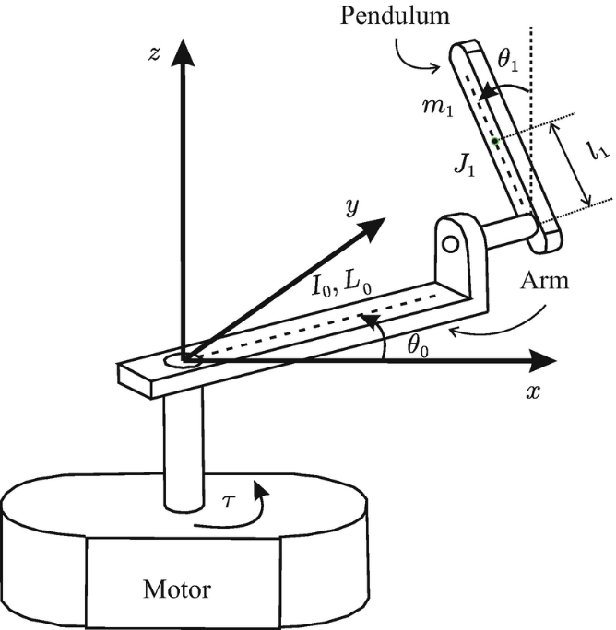

**The system inputs**

The input to the system is the torque applied from the motor.

**The system outputs**

The system output is the angular positions and the angular velocities of the arm and the pendulum.